The Case For
The claims that an Israeli attack on missiles on route to Hezbollah would ignite a war are alarmist.
Hezbollah would not dare to start a fully fledged war with Israel. It is unpopular at home and has been weakened by the Syrian war. Its supporters don't have an appetite for war.
If these missiles were to reach Hezbollah, it would strengthen their capability of attacking Israel.
The likelihood is that Hezbollah would react in a limited manner. This limited response ( eg an over border skirmish) would be a price worth paying.
There are precedents for such an action. Israel in the past has carried out such an attack and the response has been limited and some cases Hezbollah was so embarrassed it denied the action ever took place.
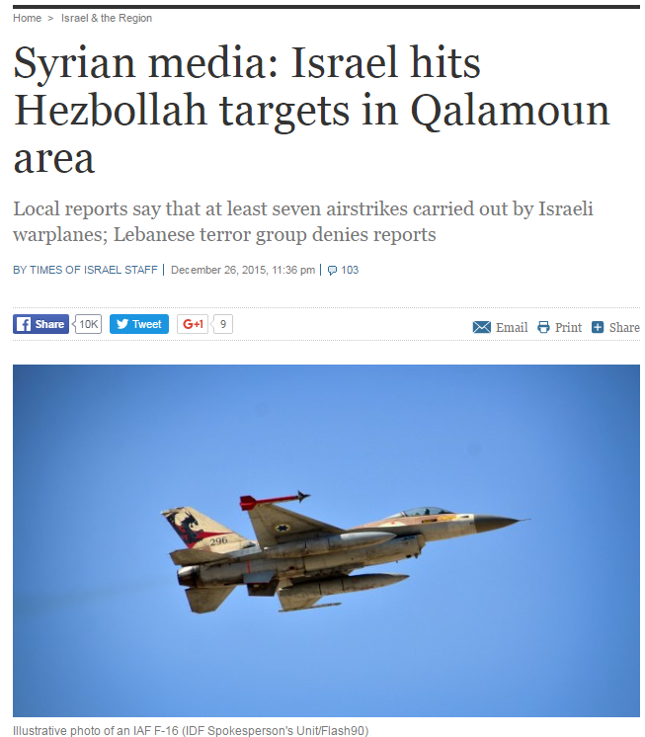

To wait would guarantee that these missiles would be hidden in a densely populated civilian area. This would mean that their destruction would necessitate a higher civilian casualty rate.
The attack would be supported by pro Saudi Sunni countries who are threatened by Hezbollah as well as Europe and the US.
Israel does not have to take responsibility for the strike and could describe such claims as speculation.
Source and further reading:

Nasrallah Admits Weakened Hezbollah No Match for Israel
www.israelnationalnews.com/News/News.aspx/193926#.VwY5hPl95aQ

Nasrallah Admits Weakened Hezbollah No Match for Israel ...
www.israelvideonetwork.com/nasrallah-admits-weakened-hezbollah-no-..
Hezbollah's revenge against Israel shows a weakened terrorist organization
http://www.jpost.com/Arab-Israeli-Conflict/Analysis-Hezbollahs-revenge-against-Israel-shows-a-weakened-terrorist-organization-439449

