Background
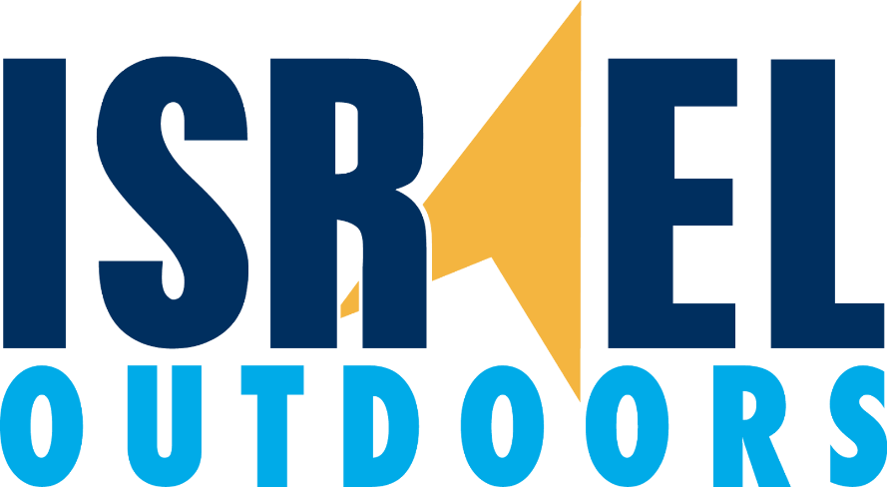

Israel's Northern Border
Israel's security situation in the North has been rapidly changing since the beginning of the Syrian civil war. Today Israel is facing new challenges both in Syria and Lebanon from Al Qaeda and other radical Sunni groups and radical Shiites such as Hezbollah that are backed by Iran.
The casualties in the Syrian war are horrendous. By December 2015 the Syrian conflict has claimed the lives of some 250,000 people, according to the U.N., and more than half of the country’s population of 22 million has been displaced. Millions have fled overseas. 1
Backed by Iran Hezbollah, previously active only in Lebanon, has sent troops to fight upon half of the Syrian regime. Backed by Assad, Iran and now the Russians, Hezbollah has become a dangerous and well-armed adversary to Israel.
1 International Business Times http://www.ibtimes.com/syrias-civilian-death-toll-number-isis-victims-2015-much-less-assad-regime-inflicted-2242839

Hezbollah Background
Hezbollah, or the Party of God, is a well-financed, Iranian backed, Lebanese based Shiite organization that acts to implement the foreign policy of Iran by other means. Its operations span across Europe, Asia and Latin America. Today it effectively controls large areas of Lebanon, hiding many of its rockets in civilian areas.
The Second Lebanon War saw Hezbollah launch thousands of rockets at Israel. It is estimated that during the War 1300 Lebanese were killed and 165 Israelis. It is further estimated that anywhere up to 500,00 Israelis were displaced and nearly 1 million Lebanese.
The situation today is very different from what was perceived by the UN at the end of the war. The UN envisaged the disarmament of Hezbollah, the withdrawal of the IDF from Lebanon, and for the deployment of the Lebanese Armed Forces.
By allying themselves with Russia and being backed by Iran, Hezbollah has emerged as one of the largest threats to Israel to date. Armed with state of the art missiles and rockets, Hezbollah has the means to attack many sites in Israel. It is stronger than many of the conventional armies in the region.
Hezbollah's involvement in the Syrian War has been a double edged sword. Hezbollah emerges from the war with real time experience. It has become trained in real combat scenarios and can use much of its Russian or Iranian provided equipment. Hezbollah has, however, suffered casualties in the war. It is estimated that between 1,300 to 1,500 of its fighters have been killed in Syria, that's around a third of its fighters on the ground.
The Threat from Hezbollah
Hezbollah continues to threaten Israel. It is estimated to have around 160,000 rockets. In a recent speech their leader Hassan Nasrallah, threatened to attack Israel's chemical plant in Haifa, guaranteeing thousands of Israeli deaths in a future war. Nasrallah claimed the attack would be the equivalent of a nuclear attack on Israel. Israel's security officials see Hezbollah as a major threat to Israel. Hezbollah's extensive arsenal is hidden in the densely populated. civilian areas of Southern Lebanon. Given this new reality, Israel would have to consider what its future strategy would be in a war so as to avoid mass civilian casualties.
It is estimated that Hezbollah would be able to launch thousands of rockets per day at Israel in any future war. Compared to 100 per day in the last war. What is clear is that the missiles Hezbollah gained are a major security threat to Israel.
A report (May 2015) in As Sarif, a pro Hezbollah Lebanese paper, revealed how Hezbollah has prepared a network of tunnels, similar to those used by Hamas in Gaza, along the Israeli – Lebanese border. The newspaper also reports that Hezbollah's tunnels are fully equipped with ventilation systems, camouflaged exit ports, and that tens of thousands of rockets.
Hezbollah could not only aim at every city in Israel, the Israeli air force and civilian aircraft would not be immune Hezbollah possesses long range missile s as well as anti-aircraft missiles. It also has drones that can strike. In a future war it is expected that Hezbollah would seek to capture Northern kibbutzim in Israel. The group could attempt to attack Israel from Lebanon and Syria spontaneously.
The rise of Hezbollah has seen as a threat by many Arab countries too. Recently the Arab League declared Hezbollah a terrorist organization. The United States, Canada and Australia have listed Hezbollah as a “terrorist” group together with the Europeans. In January, Bahrain said it had discovered a terrorist cell related to Hezbollah. Likewise, Kuwait sentenced 22 people for spying with Hezbollah.

Further Reading Times of Israel. Nasrallah threatens chemical plant.
http://www.timesofisrael.com/nasrallah-threatens-to-bomb-chemical-plants-kill-thousands-of-israelis/
The Washington Institute. A war like no other
http://www.washingtoninstitute.org/policy-analysis/view/a-war-like-no-other-israel-vs.-hezbollah-in-2015
Haaretz
http://www.haaretz.com/israel-news/1.657790

